**National University of Modern Languages**

**Assignment#02**

**Roll # 2340**

**Class: BSCS 5B Morning**

**Subject: ADVANCE OOP**

**Submitted to: Mr. Imran Ahsan**

**Submitted by: Farhan Haider**

**About:** By collections, also perform some operations on array list of books.

ADD:

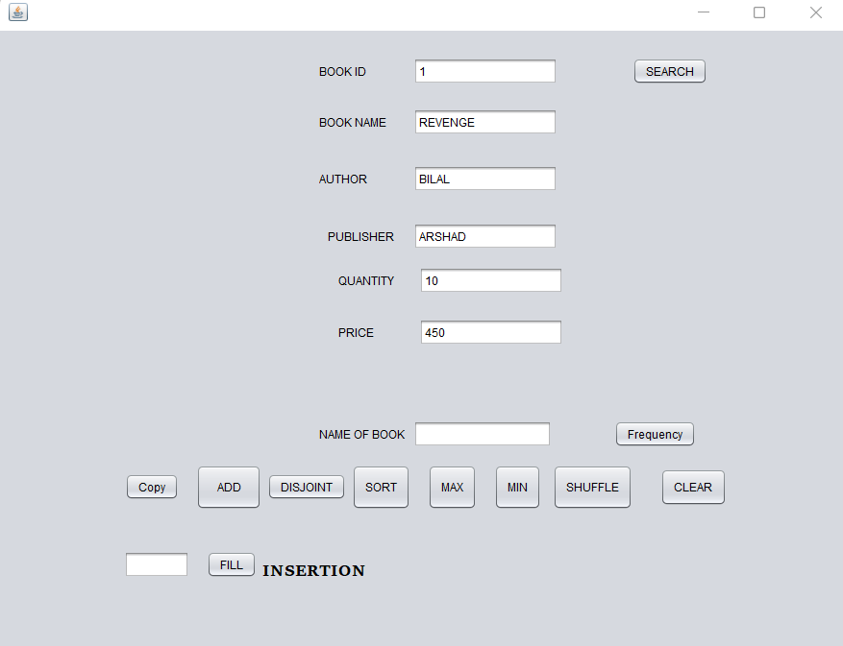

SEARCHING

DISJOINT

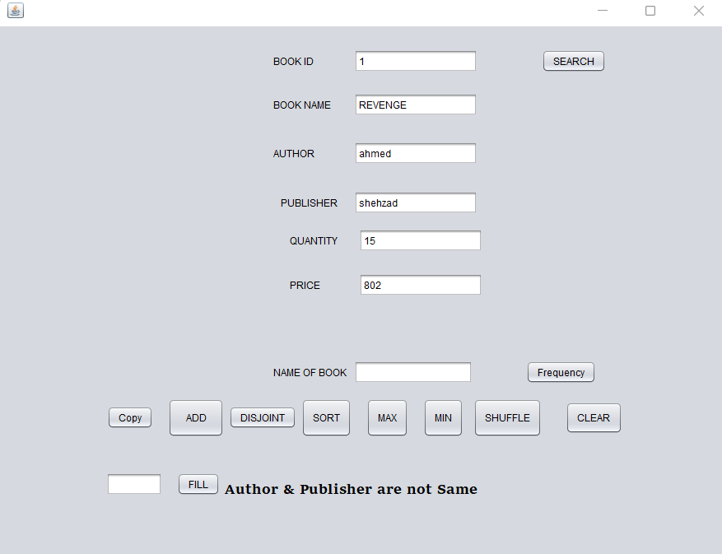

MAX

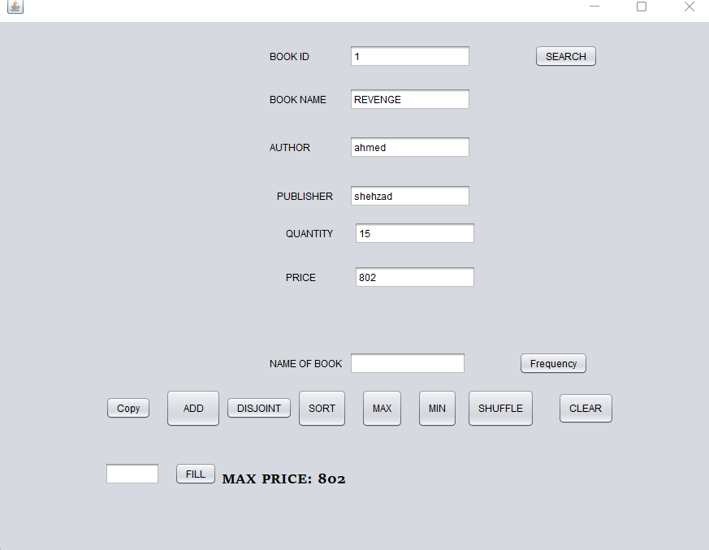

MIN:

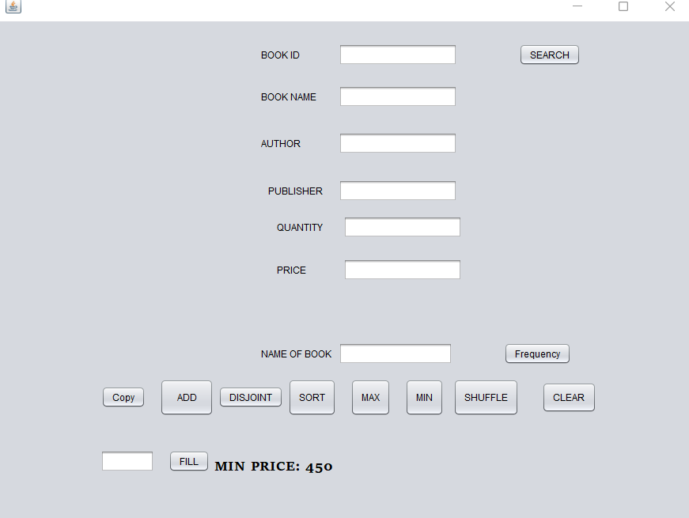

FREQUENCY:

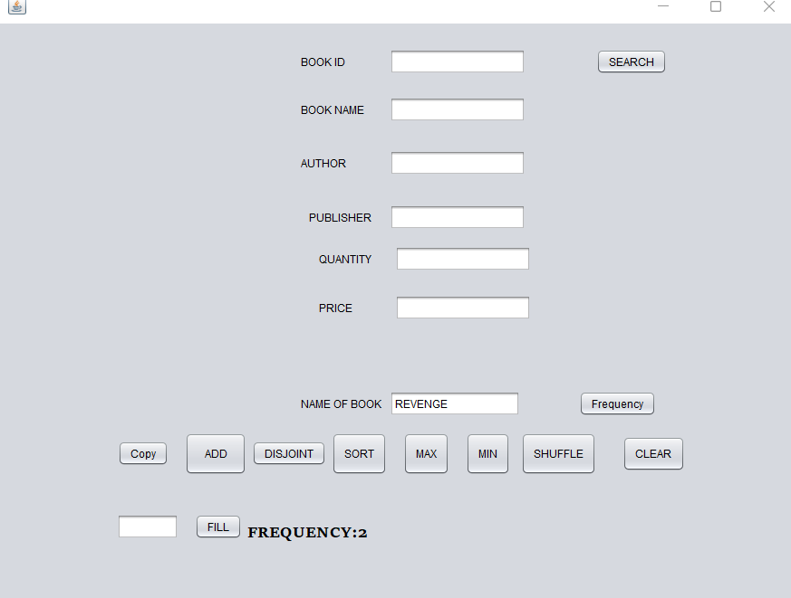

FILL:

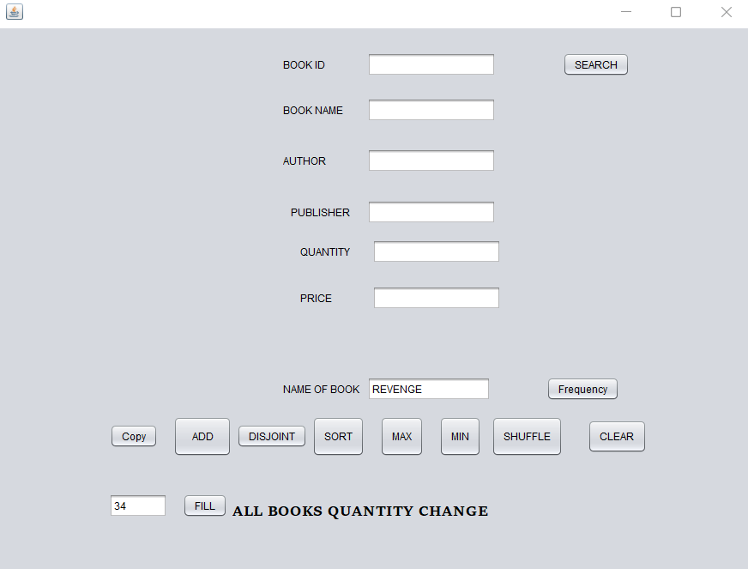

COPY:

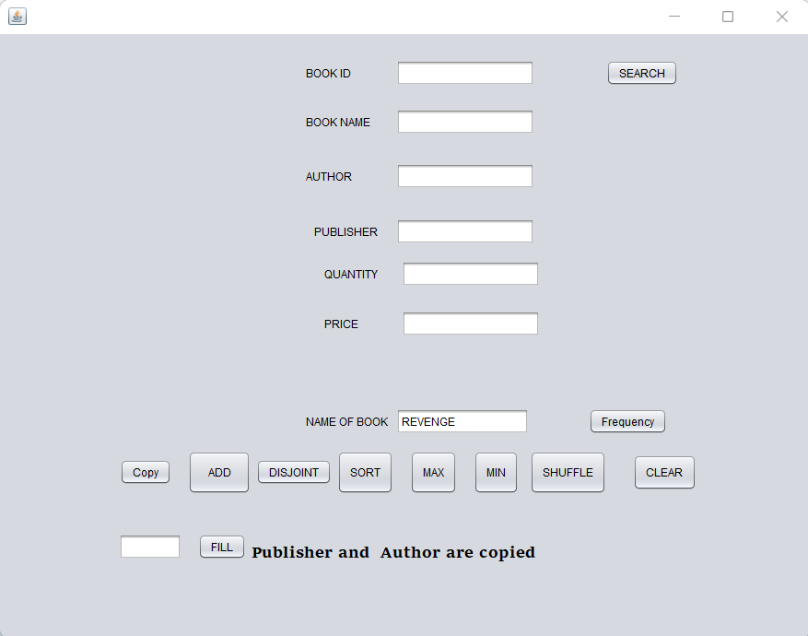

SHUFFLE:

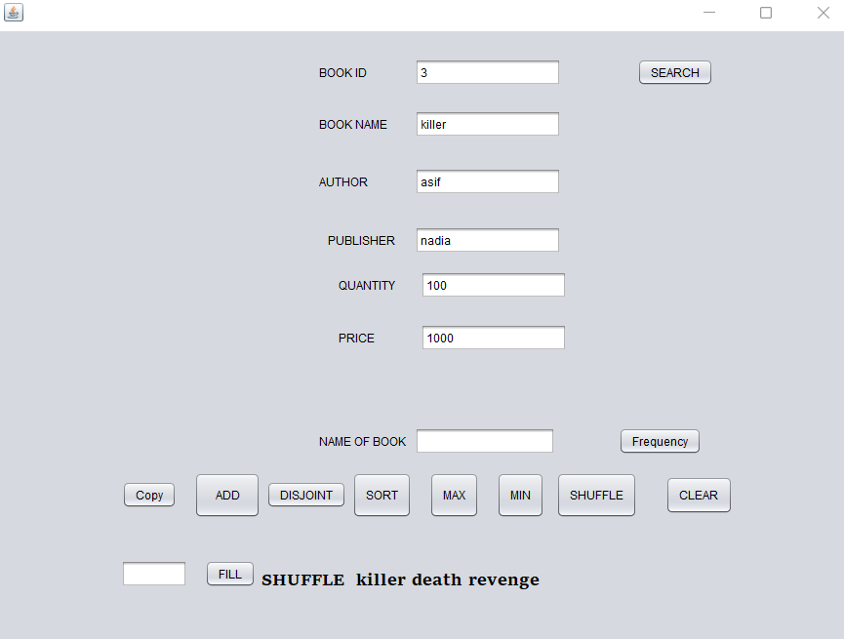

SORT:

